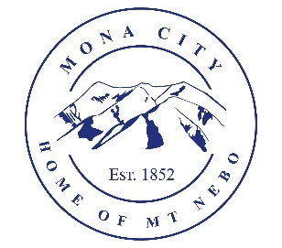
Mona City
435-623-4913
www.monacity.gov
20 West Center Street Mona, Utah

Mona City Council Meeting Agenda
Tuesday, January 9, 2024
7:00 p.m.

- Pledge
- Prayer
- Approval of December 12, 2023, work session minutes
- Approval of December 12, 2023, city council meeting minutes
- Action Items:
  - Oath of Office for new Mona City Councilmembers
  - Brett Lynn: Mona City Shooting Range Suggestions
  - Chris Neilson – emergency preparedness and management
  - Kimo & Doris Coray – panels at green waste site
  - Jones and Demille – joint highway committee funding approval of the 200 North reconstruction project
- Secretary:
- Planning & Zoning:
  - Brent Blackwell – Accessory Building Permit – 587 Center Street
- Director of Finance:
  - Approval of Finances
  - Quarterly Budget Report
- Gas & Water & Roads:
- Sewer:
- Recorder:
  - Mona City Code review
- Council Reports:
- Public Comment:
- Adjournment

CERTIFICATE OF POSTING
This agenda is hereby properly advertised this 8th day of January, 2024, through posting of copies of this agenda in the following places: the Mona City Office, at the United States Post Office Mona City Branch, and on the Utah Public Notice Website at www.utah.gov/pmn/index.html.

_____________________________________
Alicia Hills, Mona City Recorder

Upon Request, in compliance with the Americans with Disabilities Act, reasonable accommodations for individuals with disabilities will be provided. For assistance, please call 435-623-4913.

