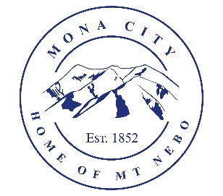
Mona City
435-623-4913
www.monacity.org
20 West Center Street Mona, Utah

Mona City Council Executive Session and Work Session
Tuesday, January 9, 2024
6:00 pm

Notice is hereby given that the Mona City Council will hold an executive session and work session and on Tuesday, January 9, 2024, at 6:00 p.m. in the Mona City Council Chambers located at 20 West Center Street, Mona City. The purpose of the executive session is discussion concerning potential litigation. The purpose of the work session is discussion on the following:

- Budget follow-up
- Ordinance suggestions
- Councilmember Responsibilities
- Snack Shack rental update
- Non-profit update

CERTIFICATE OF POSTING

This agenda is hereby properly advertised this 8th day of January 2024, through posting of copies of this agenda at the Mona City Office, at the United States Post Office located in Mona City, on the Mona City website, and on the Utah Public Notice Website at www.utah.gov/pmn/index.html.

_______________________________________
Alicia Hills
Mona City Recorder

Upon Request, in compliance with the Americans with Disabilities Act, reasonable accommodations for individuals with disabilities will be provided. For assistance, please call 435-623-4913.

