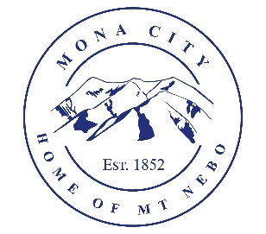
Mona City
435-623-4913
www.monacity.org
20 West Center Street Mona, Utah

Mona City Council Work Session and Executive Session Agenda
Monday, March 18, 2024
6:00 pm
Mona City Council Room – 20 West Center

Notice is hereby given that the Mona City Council will hold a work session and executive session on Monday, March 18, 2024, at 6:00 p.m. in the Mona City Council Chambers located at 20 West Center Street, Mona City. The purpose of the open work session is to discuss the following:

- Building reservations for recreation program

The purpose of the closed executive session is to hold a strategy session in accordance with Utah Code 52-4-205.

CERTIFICATE OF POSTING

This agenda is hereby properly advertised this 14th day of March 2024, through posting of copies of this agenda at the Mona City Office, at the United States Post Office located in Mona City, on the Mona City website, and on the Utah Public Notice Website at www.utah.gov/pmn/index.html.

_______________________________________
Alicia Hills
Mona City Recorder

Upon Request, in compliance with the Americans with Disabilities Act, reasonable accommodations for individuals with disabilities will be provided. For assistance, please call 435-623-4913.

