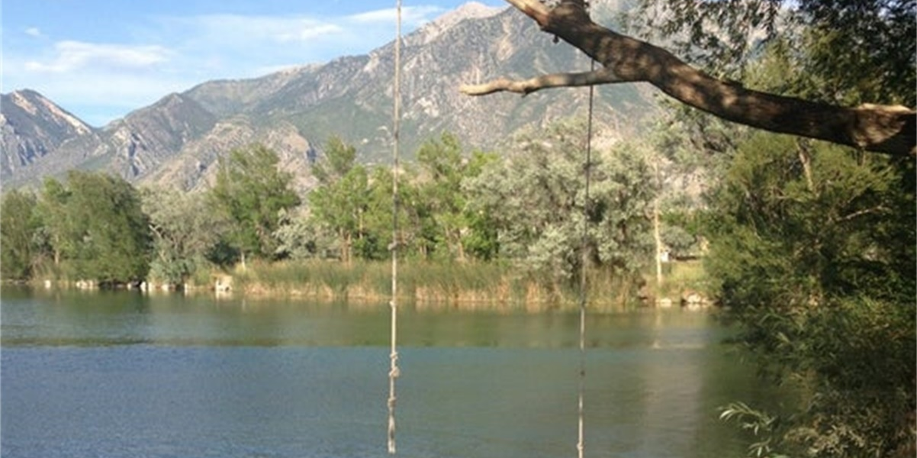
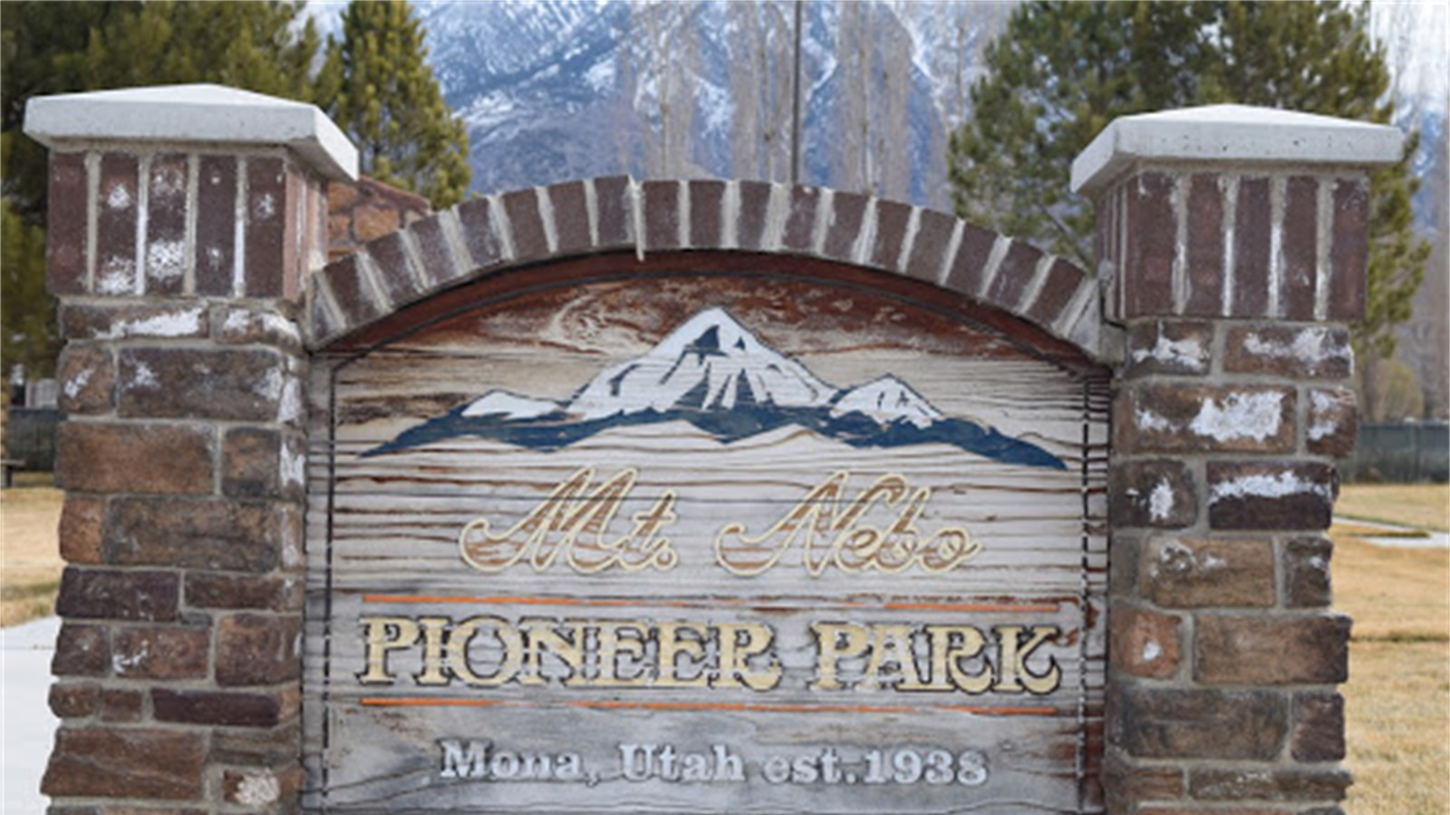
Mona City, Utah

Parks & Recreation

Impact Fee Facility Plan &
Impact Fee Analysis

March 22, 2021

Draft

Impact Fee Facility Plan (IFFP) Certification
Jones & DeMille Engineering (JDE) and EFG Consulting (EFG) certify that the attached impact fee facilities plan:
- includes only the costs of public facilities that are:
  - allowed under the Impact Fees Act; and
  - actually incurred; or
  - projected to be incurred or encumbered within six years after the day on which each impact fee is paid;
- does not include:
  - costs of operation and maintenance of public facilities;
  - costs for qualifying public facilities that will raise the level of service for the facilities, through impact fees, above the level of service that is supported by existing residents;
  - an expense for overhead, unless the expense is calculated pursuant to a methodology that is consistent with generally accepted cost accounting practices and the methodological standards set forth by the federal Office of Management and Budget for federal grant reimbursement; and,
- complies in each and every relevant respect with the Impact Fees Act.

Impact Fee Analysis (IFA) Certification
JDE and EFG certify that the attached impact fee analysis:
- includes only the costs of public facilities that are:
  - allowed under the Impact Fees Act; and
  - actually incurred; or
  - projected to be incurred or encumbered within six years after the day on which each impact fee is paid;
- does not include:
  - costs of operation and maintenance of public facilities;
  - costs for qualifying public facilities that will raise the level of service for the facilities, through impact fees, above the level of service that is supported by existing residents;
  - an expense for overhead, unless the expense is calculated pursuant to a methodology that is consistent with generally accepted cost accounting practices and the methodological standards set forth by the federal Office of Management and Budget for federal grant reimbursement;
  - offsets costs with grants or other alternate sources of payment; and,
- complies in each and every relevant respect with the Impact Fees Act.

JDE and EFG Consulting make this certification with the following caveats:
- All of the recommendations for implementations of the IFFP made in the IFFP documents or in the IFA documents are followed by District staff and elected officials.
- If all or a substantial portion of the IFFP or IFA are modified or amended by the District, this certification is no longer valid.
- All information provided to our team is assumed to be correct, complete, and accurate. This includes information provided by the District as well as outside sources.

Jones & DeMille Engineering EFG Consulting
Contents
Impact Fee Facility Plan (IFFP) Certification 2
Impact Fee Analysis (IFA) Certification 2
Section 1: Executive Summary 4
Service Area: 4
Demand Analysis: 4
Level of Service: 4
Excess Capacity: 4
Capital Facilities Analysis: 4
Funding of Future Facilities: 4
Proposed Impact Fee 4
Section 2: Demand Analysis 5
Demand Units & Future Demand 5
Historic Growth 5
Section 3: Level of Service 6
Section 4: Capital Facility and Funding Analysis 7
Capital Facilities Analysis: 7
Funding of Future Facilities: 7
Section 5: Impact Fee Calculation 8
Non-Standard Impact Fees 8
Appendix A – Draft Impact Fee Enactment 9
Appendix B – Impact Fee Calculation 10

Section 1: Executive Summary
The purpose of this Impact Fee Facility Plan (IFFP) and Impact Fee Analysis (IFA) is to fulfill the requirements of the Utah Code Title 11 Chapter 36a (Impact Fee Act) to enable Mona City (City) in enacting a parks and recreation impact fee for the City. The following is a summary of the IFFP inputs.

Service Area:
The service area for this IFFP will include the entire City.

Demand Analysis:
The demand unit utilized in this analysis was residential population. Future growth in the City is estimated to increase by an additional 374 people over the next 10 years.

Level of Service:
The Level of Service (LOS) for parks and recreation is investment per capita. Based upon the City’s current parks and recreation inventory valued at $1.9m, the investment per capita is $1,023.

Excess Capacity:
The Service Area currently has no excess capacity in its current facilities.

Capital Facilities Analysis:
Based upon the demand and LOS, the City will need to invest $383k over the next 10 years to maintain the current LOS. The City has preliminary plans for $761k in parks and recreation facilities.

Funding of Future Facilities:
The City anticipates using general fund moneys to build these facilities.

Proposed Impact Fee
Based upon the inputs above and the household size of 3.66, the maximum allowable impact fee for the City $3,745 per household. A full summary of the impact fee calculation can be found in the body of the document and the appendix. For residential units that can demonstrate a lower population density, the City reserves the right under the Impact Fee Act to use a multiplier to calculate the impact fee at $1,023 per person.

Section 2: Demand Analysis
The purpose of this section is to describe the demand unit and estimate future demand.

Demand Units & Future Demand
Demand units are measured in residents. The growth in population was estimated based upon historic growth.

Historic Growth
The following is provided by the US Census Bureau.
Year | Population | Annual Growth Rate
2018 | 1,735 | 3.2%
2017 | 1,681 | 2.0%
2016 | 1,648 | 3.8%
2015 | 1,587 | 1.5%
2014 | 1,563 | 1.6%
2013 | 1,539 | -0.1%
2012 | 1,540 | -0.3%
2011 | 1,544 | 0.4%
2010 | 1,538 | 6.3%
2009 | 1,447 | 1.7%
2008 | 1,423 | 6.8%
2007 | 1,332 | 12.4%
2006 | 1,185 | 4.4%
2005 | 1,135 | 5.7%
2004 | 1,074 | 7.2%
2003 | 1,002 | 8.1%
2002 | 927 | 2.3%
2001 | 906 | 2.4%
2000 | 885 | -7.0%
1999 | 952 | 3.3%
1998 | 922 | 5.9%
1997 | 871 | 4.2%
1996 | 836 | 9.1%
1995 | 766 | 10.2%
1994 | 695 | 8.3%
1993 | 642 | 4.4%
1992 | 615 | 1.0%
1991 | 609 | 1.2%
1990 | 602
The past 10-year average annual growth rate was 2%. The following projections utilized this 2% growth rate. Based upon these projections, this analysis estimates an additional 374 new residents to the City.
10-Year Timeframe | Ave Annual Growth Rate
2009 - 2018 | 2.0%
Year | Est. Population | Rate
2019 | 1,770 | 2.0%
2020 | 1,806 | 2.0%
2021 | 1,843 | 2.0%
2022 | 1,881 | 2.0%
2023 | 1,919 | 2.0%
2024 | 1,958 | 2.0%
2025 | 1,998 | 2.0%
2026 | 2,039 | 2.0%
2027 | 2,081 | 2.0%
2028 | 2,123 | 2.0%
2029 | 2,166 | 2.0%
2030 | 2,210 | 2.0%
2031 | 2,255 | 2.0%
New Growth
10-Years | New Population | Rate
2022-2031 | 374 | 2.0%

Section 3: Level of Service
The Level of Service (LOS) for parks and recreation is defined in this analysis as the investment per capita in parks and recreation facilities. The current value of all assets in the parks and recreation system is $1.886m. This is made up of land, equipment and other amenities as depicted in the following table.
Current Inventory
Land |  | Value
Active Park Acres | 3.74 | $ 102,850
Inactive Park Acres | 40.3 | 1,108,250
Archery | 0.74 | 20,350
Total Land Value |  | $ 1,231,450
Amenities
40' x 40' half sports court
20' x 50' pavillion and tables
Blacktop parking for 18 vehicles
2 baseball fields - youth league
30' x 30' snack shack
1 women's and men's bathroom
1 drinking fountain
Estimated Cost |  | $ 500,000
Playground Equipment
4 Swings
Merry-Go-Round
Monkey bars
2 Still bars obstacles
3 Slides on a timber tower
Original Costs |  | $ 150,000
Archery Equipment |  | $ 4,500
Grand Total |  | $ 1,885,950
The land value was estimated based upon the current value of land listed for sale within Mona City as of March 22, 2021 as summarized in the following table.
Land Comparable
 | Cost | Acres | Cost/AC
Current Listing | $ 275,000 | 10 | $ 27,500
*3/22/2021 - 1939 N Old Hwy 91, Mona

With the current population estimated at 1,843, the investment per capita is $1,023.

Section 4: Capital Facility and Funding Analysis

Capital Facilities Analysis:
Based upon the demand and LOS, the District will need to invest $383k in new facilities to support new growth. The following are estimated facilities the City contemplates building.
Proposed Future Facilities
Project 1 |  | Value
Pickle Ball Court |  | $ 11,000
Project 2 |  | Value
2 High School size baseball fields
Soccer Field
Pavilion
Playground equipment
Parking
Fishing ponds
Connection trail
Skate Park
Total Land Value |  | $ 750,000
Grand Total |  | $ 761,000

Funding of Future Facilities:
The City anticipates using general fund monies to build all facilities.

Section 5: Impact Fee Calculation
Based upon the inputs above and the household size of 3.66, the maximum allowable impact fee for the City $3,745 per household. A full summary of the impact fee calculation can be found in the body of the document and the appendix.

Non-Standard Impact Fees
For residential units that can demonstrate a lower population density, the City reserves the right under the Impact Fee Act to use a multiplier to calculate the impact fee at $1,023 per person.

Appendix A – Draft Impact Fee Enactment

Appendix B – Impact Fee Calculation

US Census Bureau
US Census Bureau

